

User Interface Design (23CSE113)
LAB MANUAL

Submitted by
Name | E. Ujval Sriteja
Roll No | AV.SC.U4CSE25107
Year/Sem/Section | 1st YEAR/SEM-2/CSE-B
Submitted to
Name | Dr. Rajkumar Batchu
Department | CSE

1.MAKE A CLONE OF ANY WEBSITE
AIM: MAKE A CLONE OF ANY WEBSITE

SELECTED WEBSITE:
XIAOMI WEBPAGE
https://www.mi.com/in/
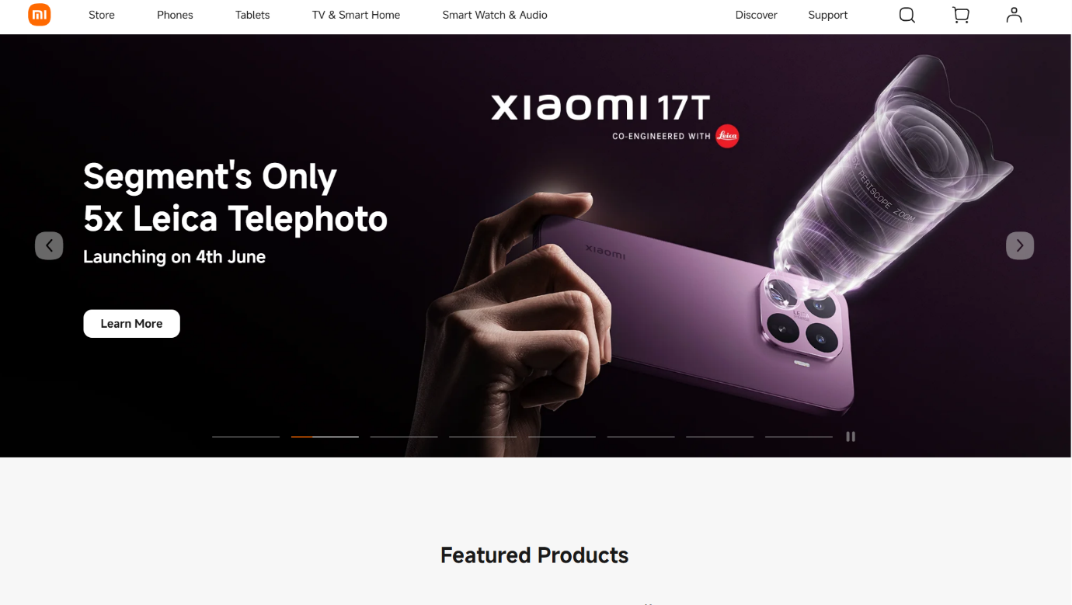
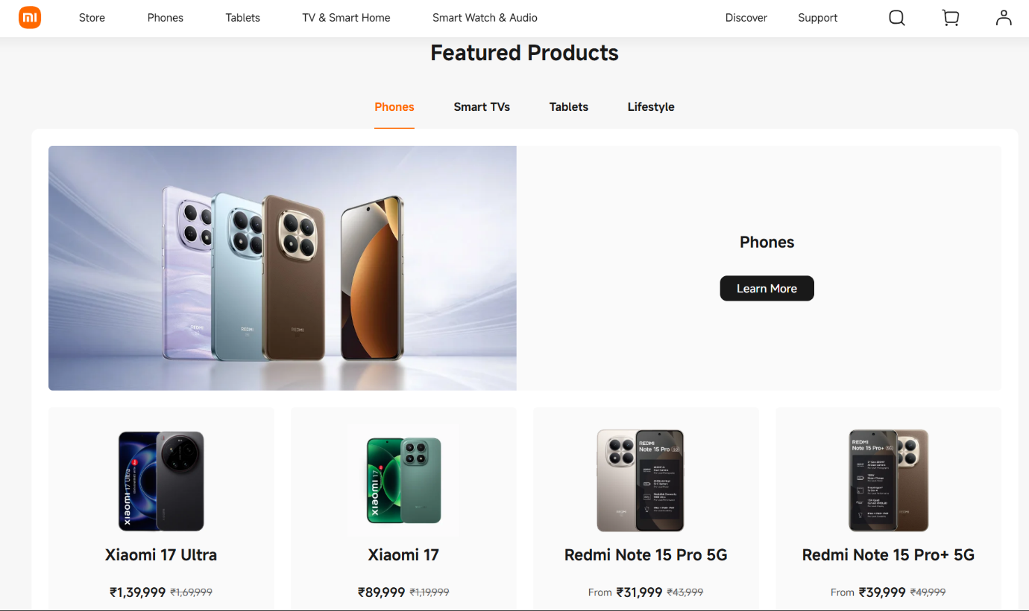

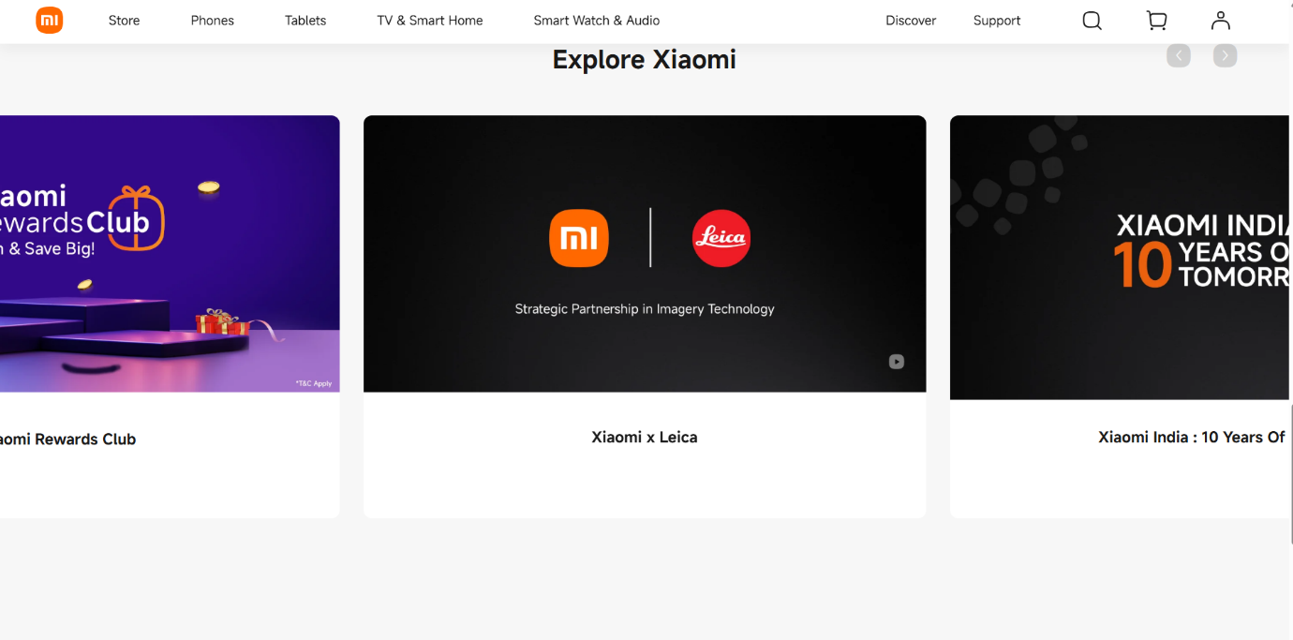

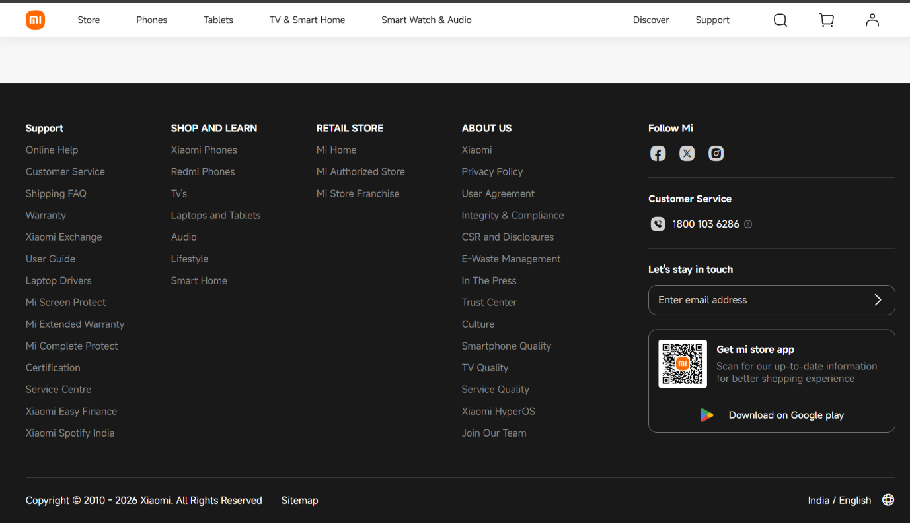

PROGRAM:
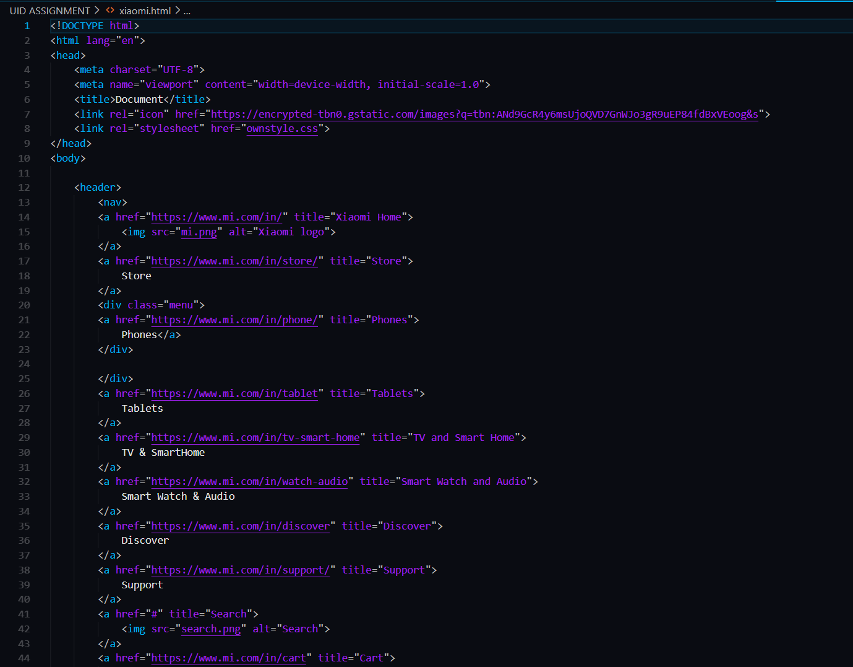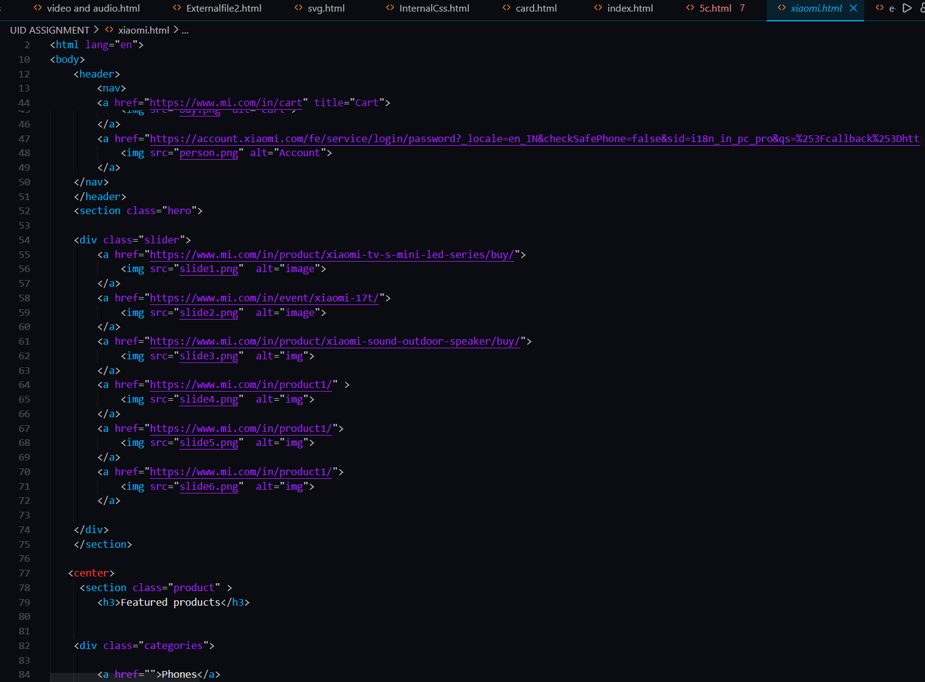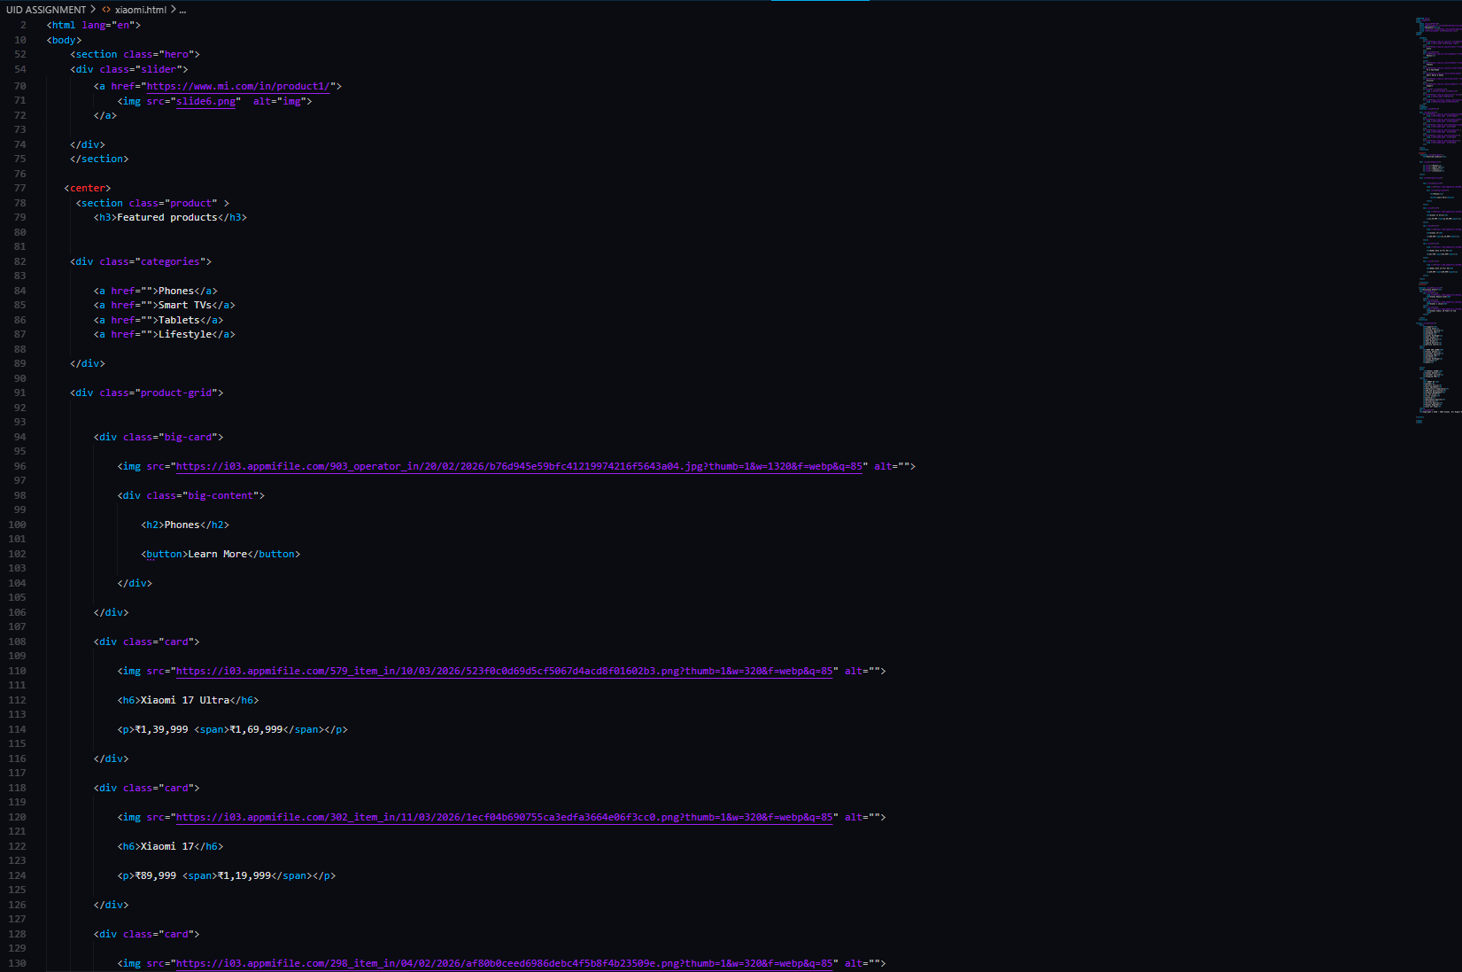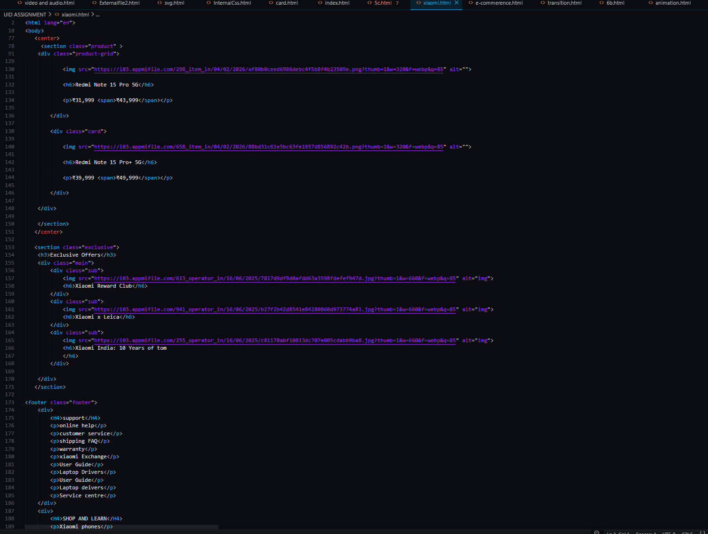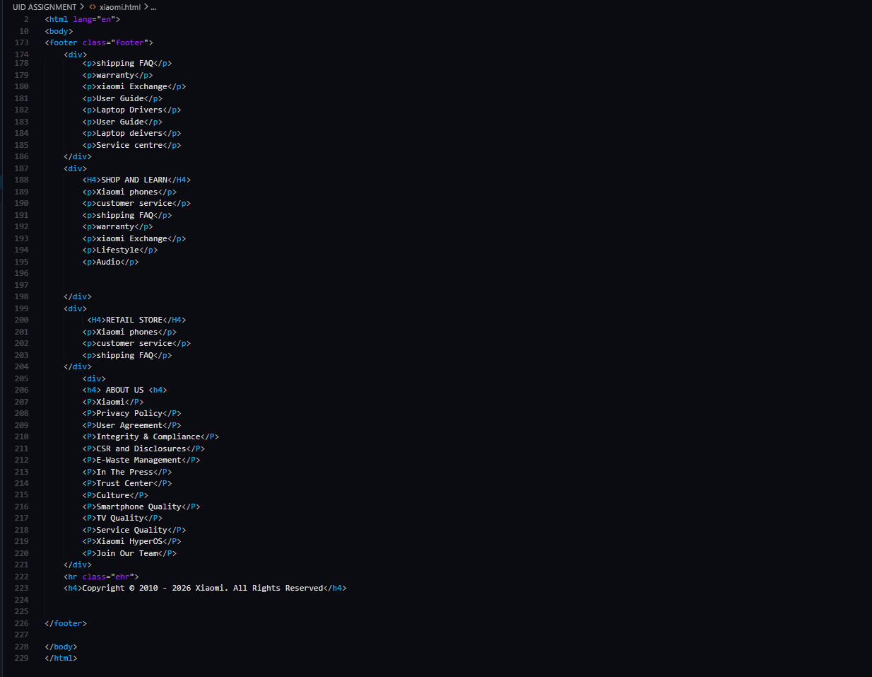
CSS:
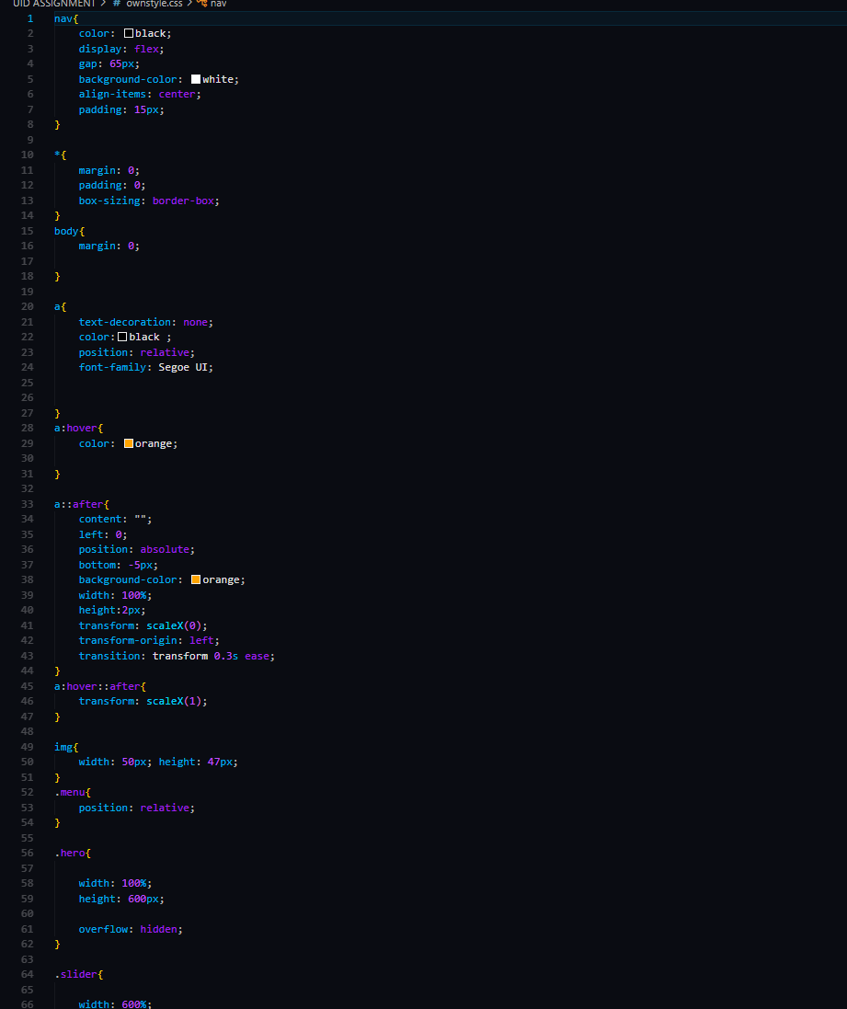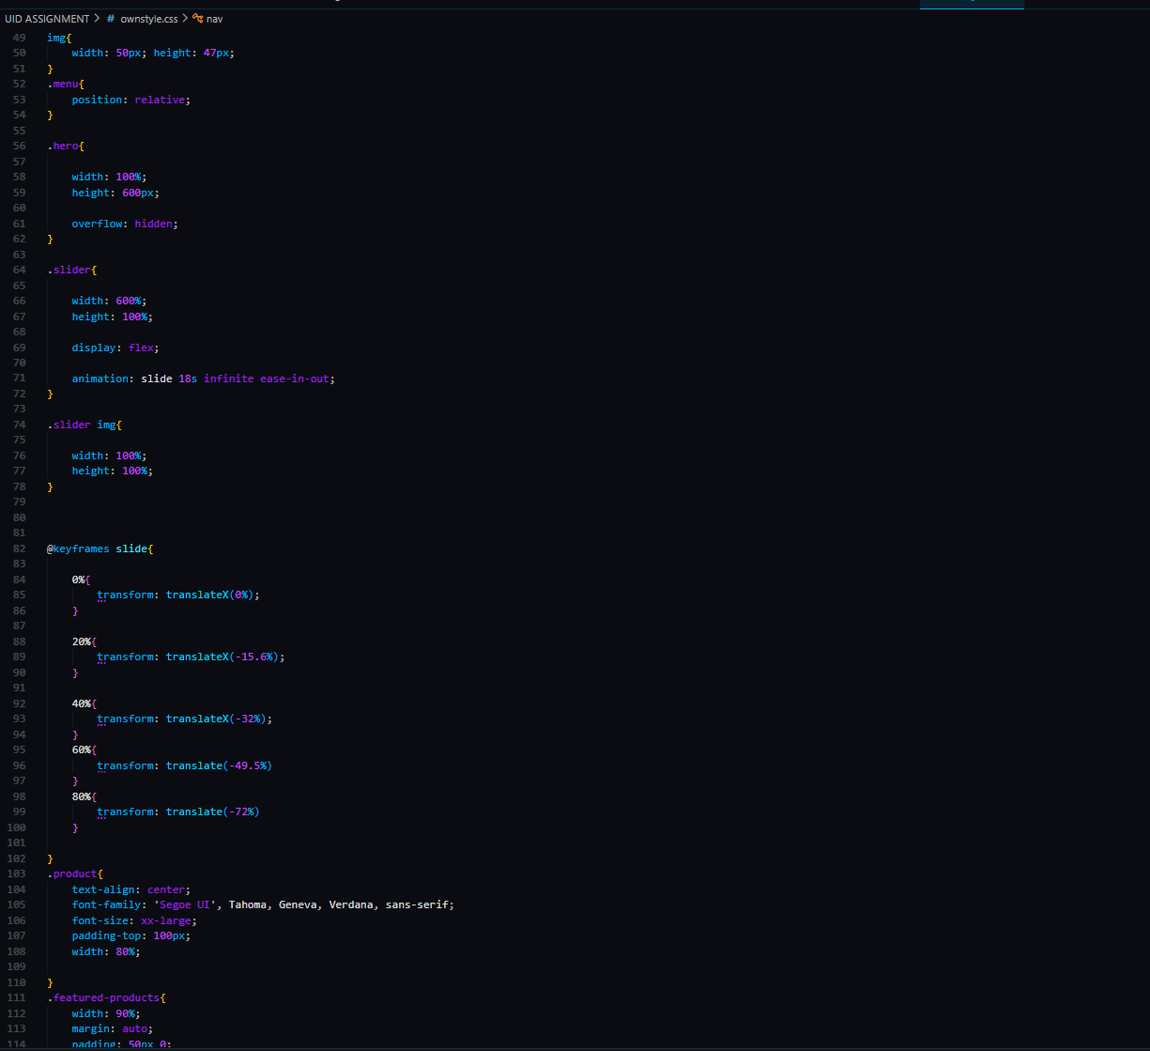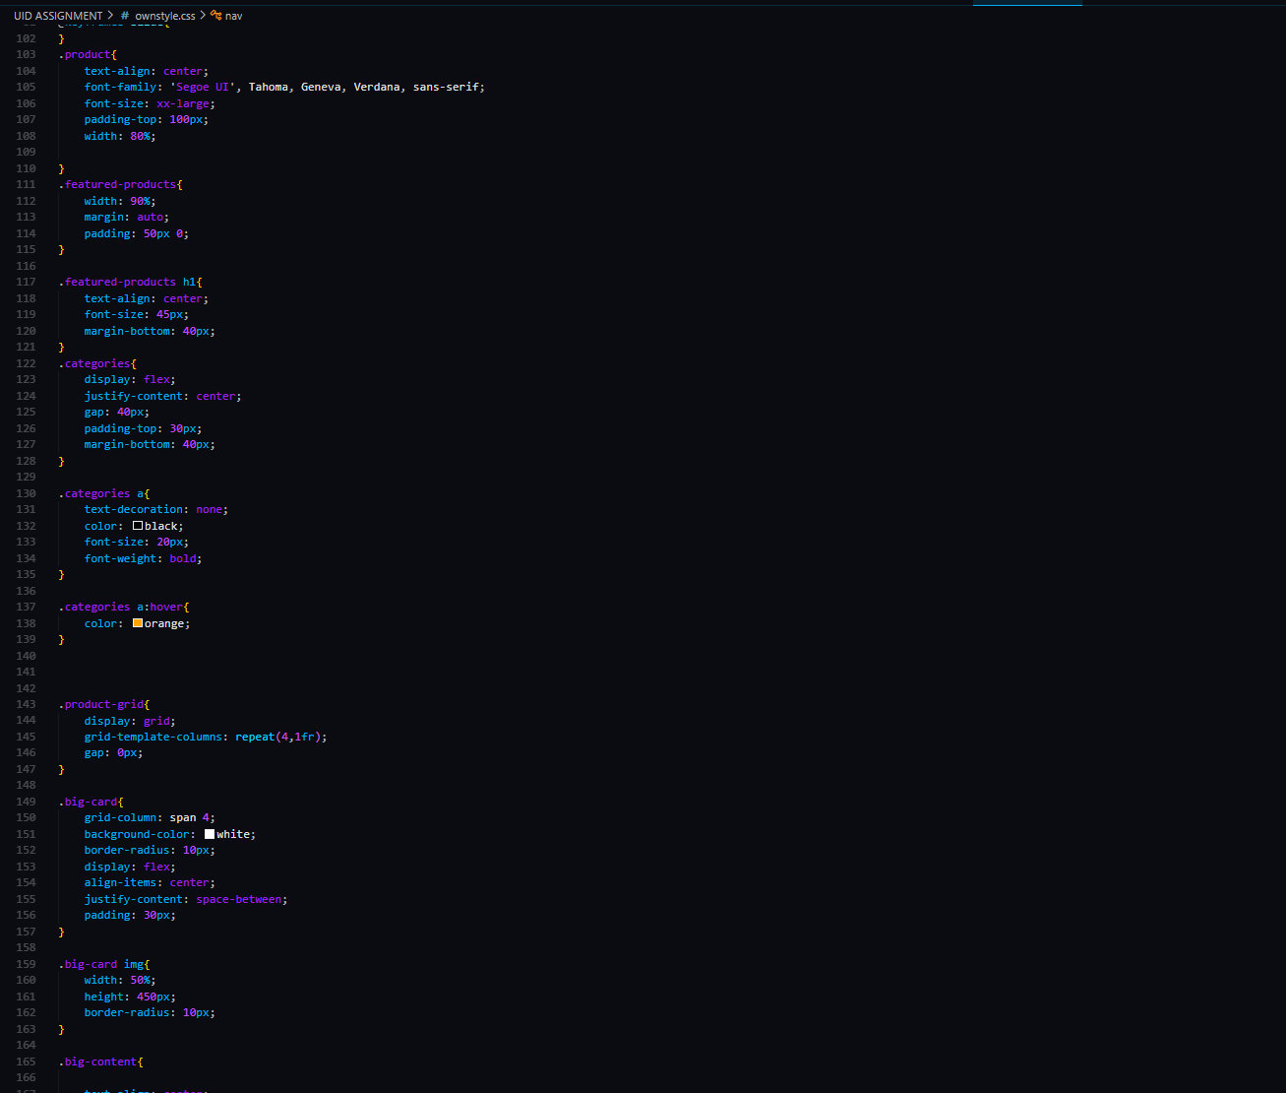
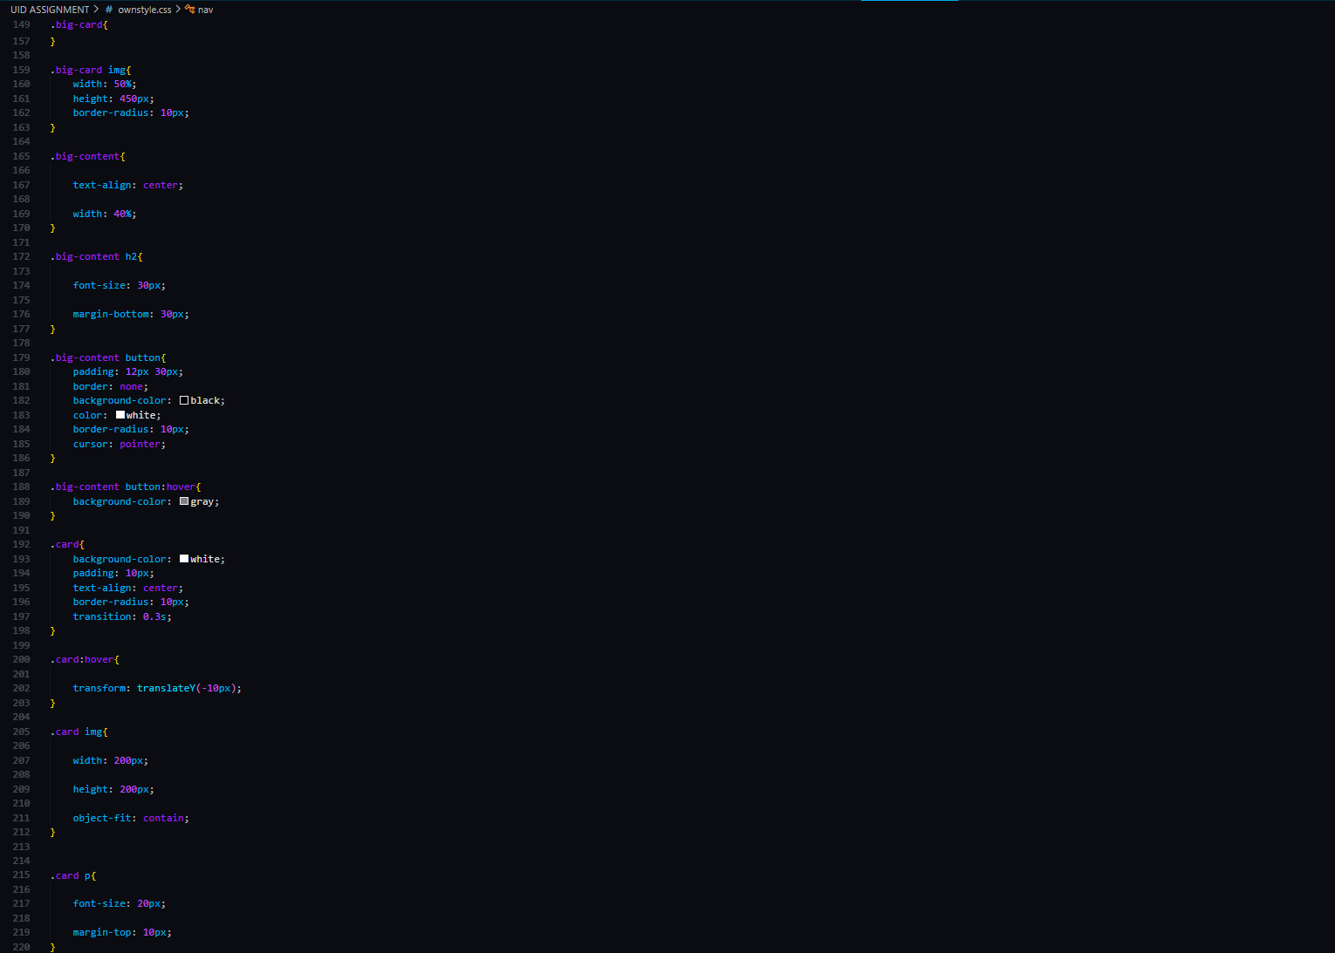

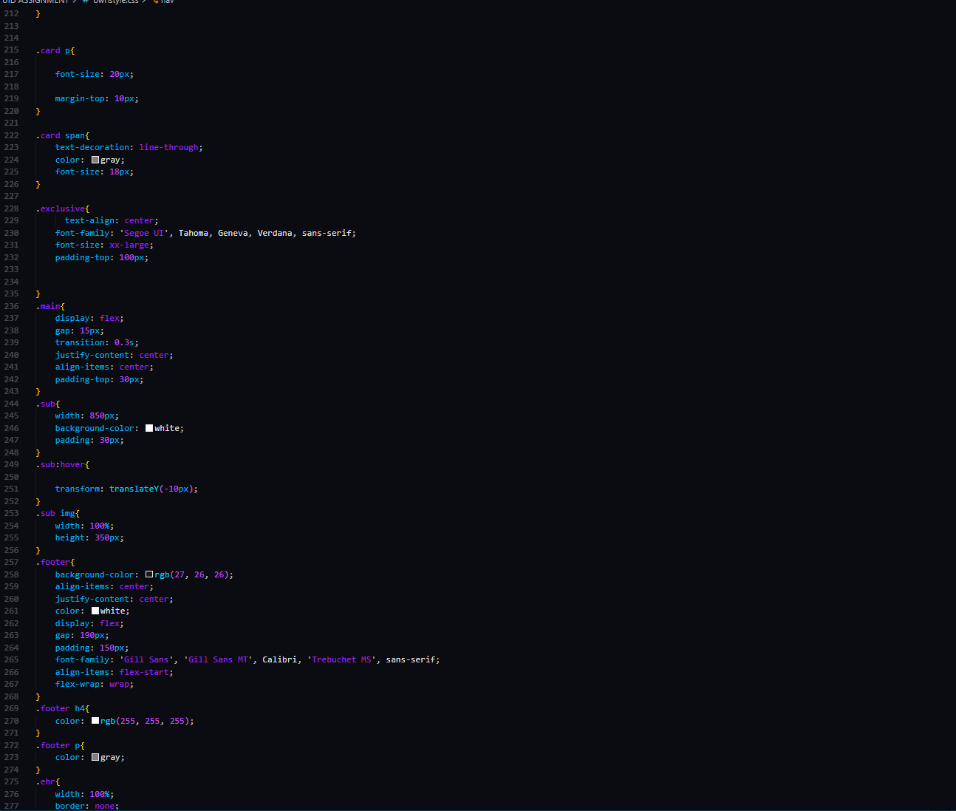

OUTPUT:
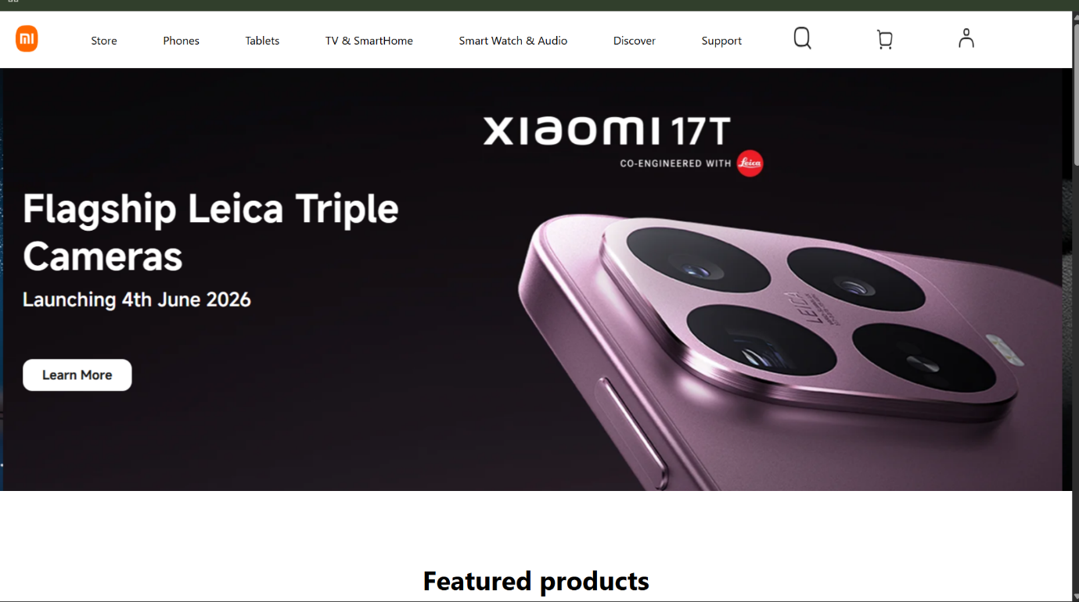

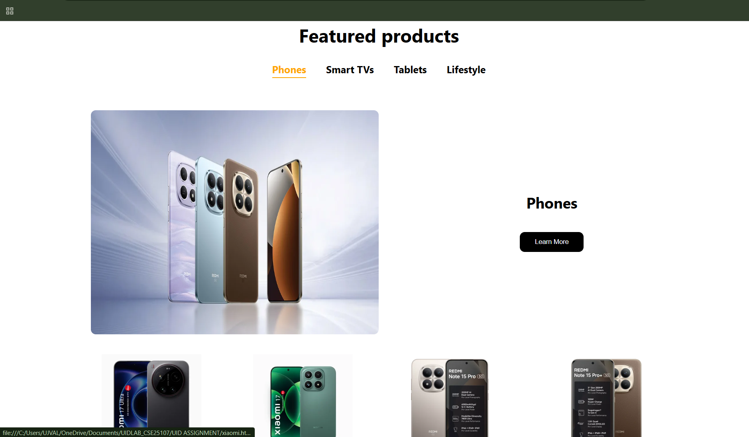

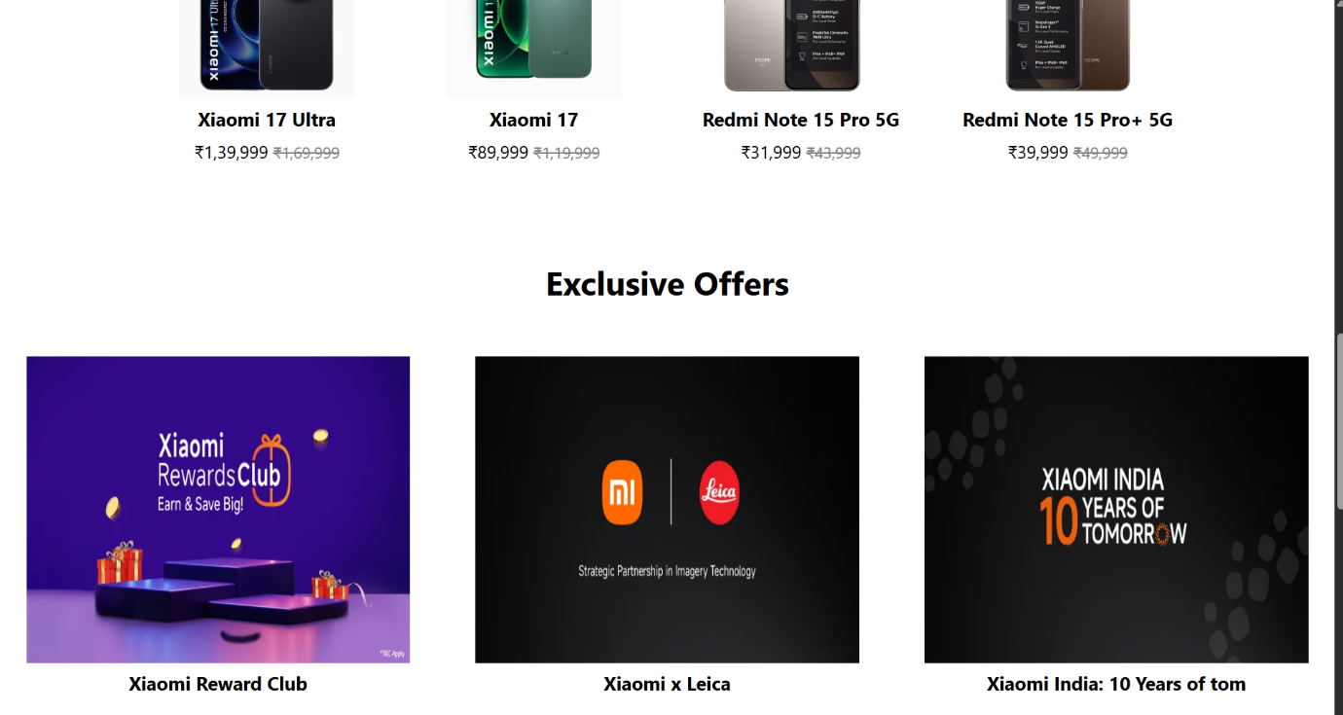
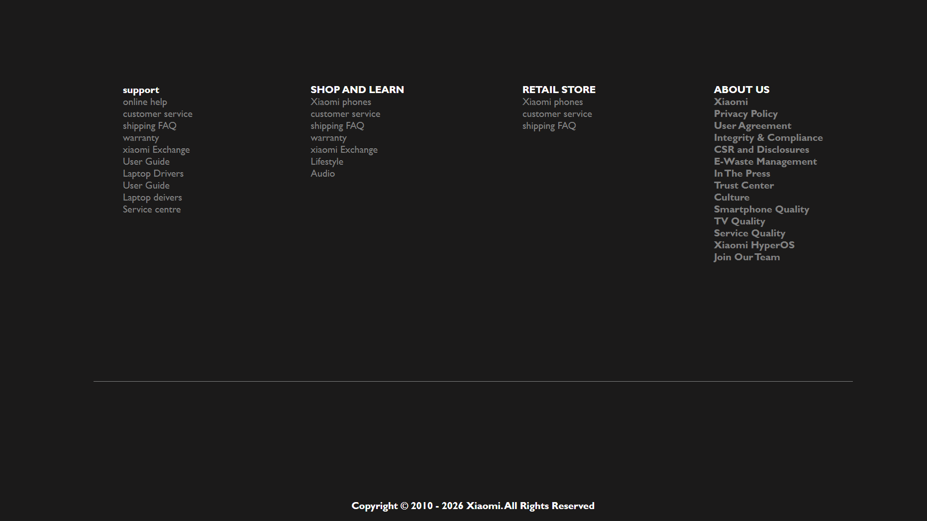

Explanation:
- Navigation Bar – Created a navigation bar to help users move between different sections of the website.
- Hover Effect on Links – Added an orange underline effect when the mouse is placed on menu items.
- Image Slider – Created an automatic image slider to display Xiaomi advertisements and offers.
- Featured Products Section – Added a section to show important Xiaomi products.
- Product Categories – Included categories like Phones, Smart TVs, Tablets, and Lifestyle products.
- Product Cards – Displayed products with images, names, and prices in separate cards.
- Button Design – Added a "Learn More" button for better user interaction.
- Exclusive Offers Section – Created a section to show Xiaomi special offers and promotions.
- Hover Animation on Cards – Added a small movement effect when the user places the mouse over product cards.
- Footer Section – Added support, shopping, retail store, and company information in the footer.
- External Links – Connected menu items to Xiaomi's official web pages.
- Image Integration – Used images to make the website attractive and user-friendly.
- Layout Management – Used CSS to arrange content properly on the webpage.
- Color and Styling – Applied colors, fonts, and spacing to improve the website's appearance.
- Structured Webpage Design – Organized the webpage using sections such as header, products, offers, and footer.
Concepts Used
- HTML for webpage structure
- CSS for styling
- Flexbox for alignment
- Grid for product layout
- Hover effects
- Transitions
- Keyframe animation for image slider
- Images and hyperlinks

